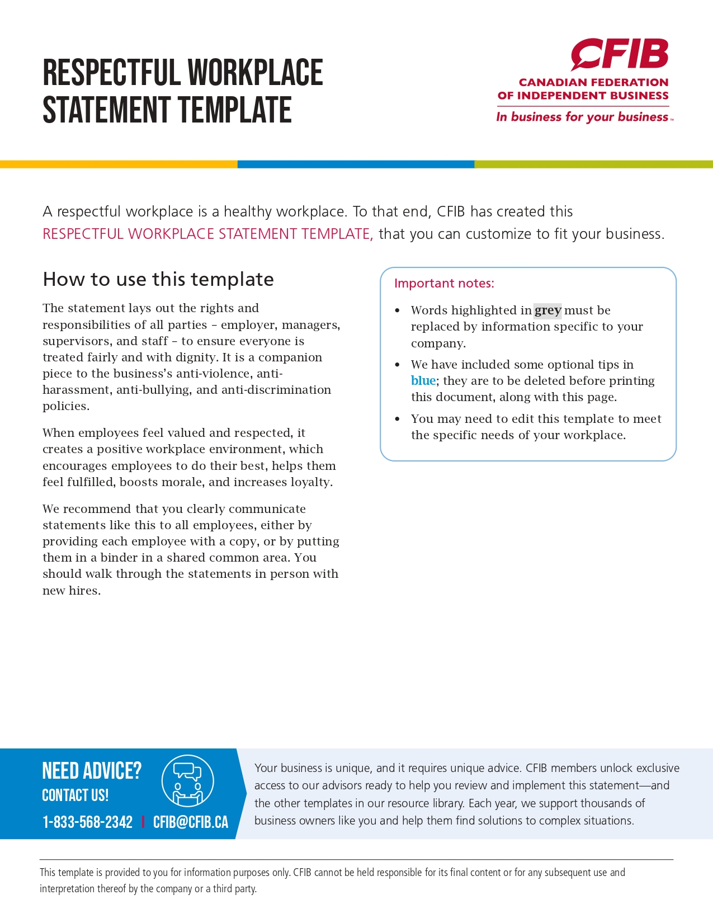
RESPECTFUL WORKPLACE STATEMENT
Name of Business fosters a respectful workplace. We value diversity, inclusion, fairness, equality, kindness, and thoughtfulness. We treat all employees with respect and dignity to create a healthy workplace where all employees contribute to and benefit from the business’s successes.
At name of business, we:
- Respect one another’s values and beliefs
- Recognise diversity as a strength
- Communicate in a respectful manner
- Maintain a workplace that is free from harassment, discrimination, bullying, and violence
- Support fundamental human rights and avoid participating in business activities that abuse human rights
- Report any inappropriate or unprofessional behaviour or speech
- Clearly communicate the consequences of unacceptable behaviour
- Provide support to those affected by inappropriate behaviour, as well as those who engage in the behaviours
- Take responsibility for our actions and decisions
Respect is:
- Listening without interrupting
- Taking the other person's feelings into consideration
- Keeping an open mind
- Agreeing to disagree
- Trying to understand the other person's viewpoint
- Trust and honesty
- Giving the other person space
- Direct communication
- Building a person up instead of tearing them down
- Not pressuring the other person
In situations where you feel the behaviour or speech of an individual goes against this statement, name of business encourages you to speak confidentially with your manager/business owner about your situation.

________________________________________
Name

________________________________________ _____________________
Signature Date

It is a best practice to give a copy to your employees for their files.

